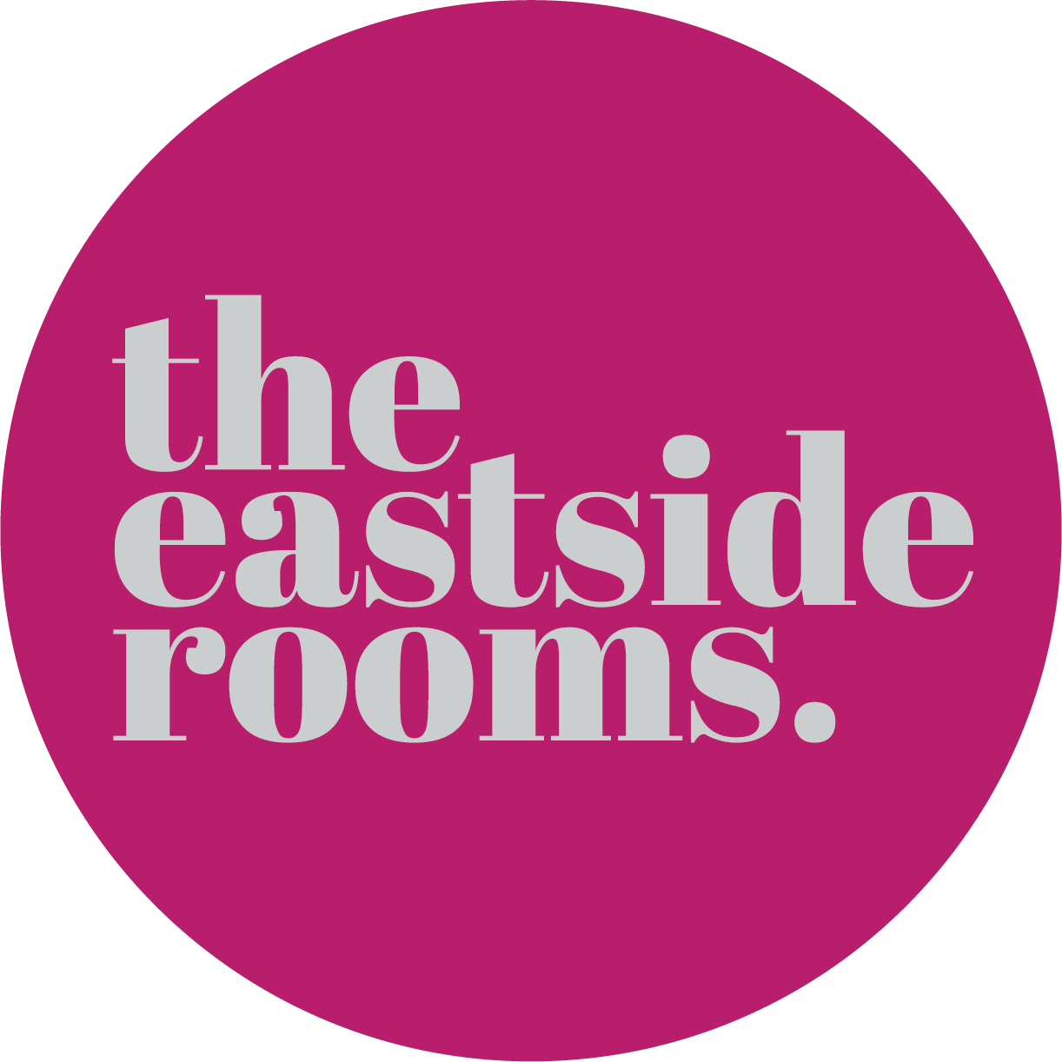

Accessibility Guide for The Eastside Rooms
sales@eastsiderooms.com, 0121 820 6060, www.eastsiderooms.com
Contact for accessibility enquiries: Tim Sparrow
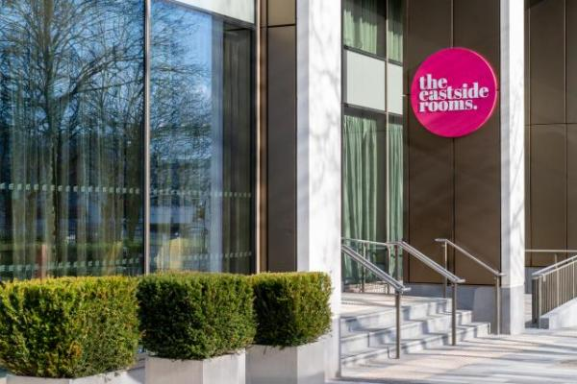

Welcome
Located in Birmingham’s Knowledge Quarter, is The Eastside Rooms, built with modern events in mind, the venue can host events both large and small, with effortless ease.
Compromised of 23 flexible meeting rooms, masses of breakout space and a stunning main suite, a 880sq. m. space, lending itself as the ideal location for conferences, banquets and exhibitions.
Plug and play technology, fresh hot coffee and catering, comfy chairs and opulent furnishings. A dedicated support team and 195-bedroomed Marriott hotel – Aloft, what else could you need to make your event exceptional?
Traditional, yet contemporary. Stylish with a touch of cool. Professionalism with a touch of fun.
Watch the video: Virtual tour of the venue

At a Glance

Level Access
- The main entrance has level access with a ramp. The ramp is permanent.
- There is level access from the main entrance to:
  - Hosts desk
  - Foyer Bar
  - Belmont Bar
  - Changing Places Facilities

Hearing
- We have a hearing loop in Affinity Suite, Meeting Room 1, Meeting Room 5, Multi Faith Room and all reception areas.
- All staff have disability awareness training.

Visual
- Glass doors have contrast markings.

General
- All staff have disability awareness training.

Getting here
Woodcock Street
Birmingham
B7 4BL

Travel by public transport
- You can get to The Eastside Rooms by bus and train.
- The venue is located on the West Midlands buses route 66 and the nearest bus stop is directly outside of the main entrance. The bus stop is 0.00 miles / 106.3 km from The Eastside Rooms.
- The nearest train station is New Street Station. The train station is 1 miles / 1.6 km from The Eastside Rooms.
- New Street Station is the main train station into Birmingham, however both Moor Street Station and Snow Hill Station are less than a mile away also.

Travel by taxi
- You can get a taxi with A2B Radio Cars by calling 0121 744 1111. The taxi company has a wheelchair accessible vehicle.

Parking
- There is parking near the venue. There are accessible parking spaces. Parking is not free.
- From the car park to the entrance, there is level access. There is a lift. The path is sloped.
- The route is 1200mm wide, or more.
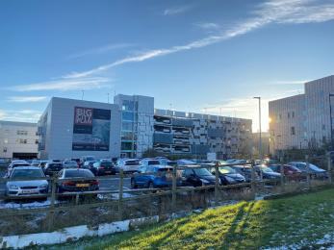
Millennium Point Car Park

Arrival

Path to main entrance
- From the street to the main entrance, there is level access.
- The path is 1027mm wide, or more.

Main entrance
- The main entrance has level access.
- There is a permanent ramp.
- The door is 2002mm wide.
- The main door is sliding and automatic.
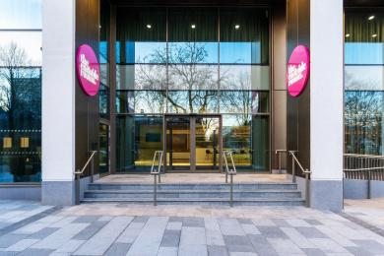
Front entrance

Getting around inside

Visual Impairment - General Information
- We have contrast markings on all glass doors.
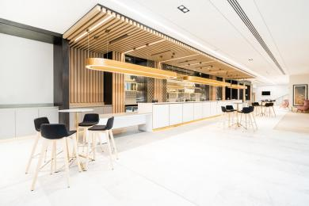
Affinity Bar And Foyer Area

Lift
- We have 2 lifts.
- You can get a lift to all floors.

All lifts
- The lift door is 1000mm wide.
- The lift is 1500mm wide. The lift is 1400mm deep.
- The lift says the floor number at each floor.
- The lift buttons have raised numbers or letters.
- The lift shows the floor number, at each floor.
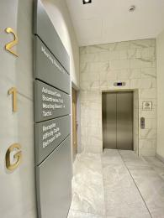
Lift entrance Area

Ticket/ information desk

Hosts desk
- From the main entrance to the desk, there is level access. The desk has a low section.
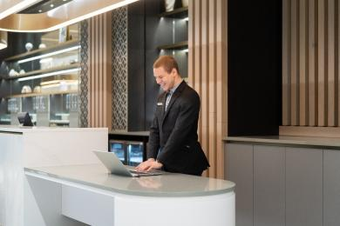
Hosts Desk

Bar

Foyer Bar
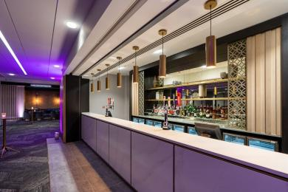
Foyer Bar
- From the main entrance to the bar, there is level access.

Bar

Belmont Bar
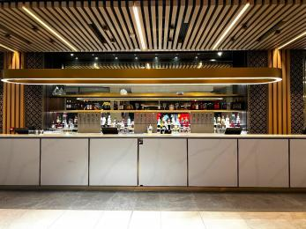
Belmont Bar
- From the main entrance to the bar, there is level access.

Public toilet

Changing Places Facilities
- There is a public toilet for disabled visitors.
- The toilet is a Changing Places toilet.
- From the main entrance to the public toilet, there is level access. The route is 1200mm wide, or more.
- The toilet door is 920mm wide.
- There is 1450mm in front of the toilet. The toilet seat is 480mm high.

Customer care support

Accessibility equipment
- We have a hearing loop in Affinity Suite, Meeting Room 1, Meeting Room 5, Multi Faith Room and all reception areas.

Emergency evacuation procedures
- We have emergency evacuation procedures for disabled visitors.

Customer care support
- All staff have disability awareness training.

Guide last updated: 16 March 2023

